**DRAWBACKS IN THIRD UMPIRE DECISION MAKING**

* Since, human may also make an error. Third umpire sitting on the review panel watching slow motion video may not be able to make actual decision in all cases. Human will make errors time-to-time. Such errors may change the rest of the game.
* The third umpire should make their decision within 45 seconds. It’s a rule that the third umpire review should not take more than 45 seconds, in order to retain the phase of the game. It’s really a challenging work for a human in more complicated decision calls.
* A problem raised after the implementation of DRS system that every batsman asked for no-ball review when his wicket is taken out. Calling DRS system several times consumes more time and more work for the third umpire. This spoil the flavor of the match.
* So, ICC came-up with a rule that a team can claim DRS only twice. There are cases that batsman knew he was not out but the wicket was taken out, since the two chances have been used.
* It’s the right of the batsman to make call for a third umpire review, which will be violated on limited DRS calls. Hence, automation is very crucial here in order to satisfy the batsman as well as it consumes very less time with image processing technologies.
* A third umpire’s salary will be about 3 to 5 lakhs INR for a match. And the technical devices could also cost much. For example, Hawk-eye method could cost about 60,000 USD for a match. Every match couldn’t accommodate such cost. Even with that there are several cons in DRS methodologies. One of the methods is discussed below.

**DRAWBACKS IN HAWK-EYE METHOD**

**Expensive:**

* Since, Hawk-eye method is based on the principle of triangulation using the visual images and timing data provided by high-speed video cameras located at different locations and angles around the area of play.

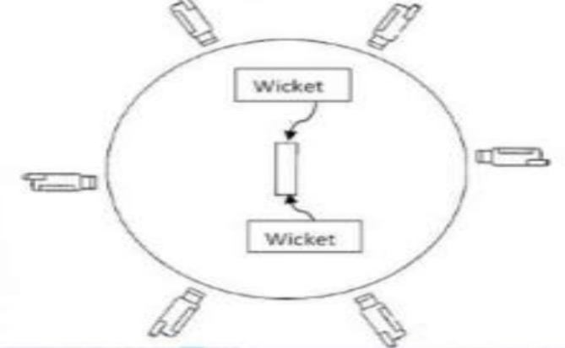

Position of Cameras around the pitch.

There are number of high-speed expensive cameras needed to implement the Hawk-Eye method which will be expensive.

* The professional Hawk-eye method for a Standard Tennis court takes 60,000 to 70,000 USD (without including Storage and computational expenses). Assuming for a large cricket stadium could cost much higher which will huge amount.

**More Computation:**

* Hawk-Eye method gets all the recorded videos from several cameras, it needs to work on several images and timing constraints in order to generate a model. This computation will be complex.
* It then, generates a 3D model from the resultant videos and timing data in order to provide output to check whether ball will hit the stump.
* These processes will take more computation and storage, which will also be expensive.

**Never work on some Natural conditions:**

* **Wind:** When there is wind, it will affect the projection of the ball. Since, Hawk-eye method decides by predicting the projection of the ball, it will result in error.
* **Pitch Conditions:** When the pitch have patches/cracks, there will be change in projection after the ball pitches. The ball may skid a bit more than normal or hit a crack, bit of grass, or worn patch of the pitch. This will be a problem.

**100% Not Accurate.**

* Since, Hawk-eye method computes the projection of the ball (prediction), there may be some deviations of the ball on actual scenario. Hence, it would not be much accurate.
* It is accepted that there will be 5mm to 15mm error deviation in detection. This could even change the victory of a team.

**LBW Rule:**

* Even though, Hawk-eye is used widely for LBW detection, the rule before implementing Hawk-eye is that it should be proved that ball touches the pad. It will not be provided by Hawk-eye method.

Our method just requires one high-speed camera for detection and lesser computation, so cost effective. It will be more reliable and accurate, not affected by natural conditions and just require proper lighting.

It provides a right for a batsman to call for a review number of times and consumes very less time with more accuracy.